**Pizza sales SQL query**

**KPIs**

**Q1. Total Revenue**

select sum (total_price) as total_revenue from pizza_sales

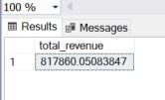

**Q2. Average Order Value**

select

sum(total_price) / count (distinct order_id) as Avg_order_value

from pizza_sales

**Q3. Total Pizzas Sold**

select

SUM(quantity) as Total_Pizza_sold

from pizza_sales

**Q4. Total Orders**

select

COUNT(distinct order_id) as Total_Orders

from pizza_sales

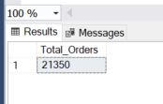

**Q5. Average Pizzas per Order**

select

SUM(quantity) / COUNT(distinct order_id) as Avg_Pizza_per_Order

from pizza_sales

-- if we run the quesry like that it will give us a whole number but there is still some decimal points missing so we use 'cast'

select CAST(

cast(SUM(quantity) As decimal(10,2)) /

cast(COUNT(distinct order_id) As decimal(10,2)) as decimal(10,2)) as Avg_Pizza_per_Order

from pizza_sales

**CHART REQUIREMENT**

**Q1. Daily trend for Total orders**

select DATENAME(DW, order_date) as order_day, COUNT(distinct order_id) as total_orders

from pizza_sales

group by DATENAME(DW, order_date)

-- 'DW'convert the date to strings e.g monday, tuesday e.t.c

**Q2. Hourly Trend for total orders**

SELECT

DATEPART(HOUR, order_time) AS order_hour,

COUNT(distinct order_id) AS Total_Orders

from pizza_sales

group by DATEPART(HOUR, order_time)

order by DATEPART(HOUR, order_time)

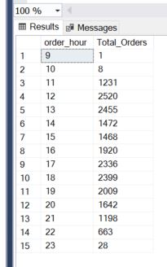

**Q3. Percentage of sales by pizza category**

SELECT

pizza_category,

SUM(total_price) AS TotalSales,

(SUM(total_price) * 100.0 / (SELECT SUM(total_price) FROM pizza_sales)) AS PercentageOfTotalSales

FROM

pizza_sales

GROUP BY

pizza_category

-- let say we want to get in respect to month

SELECT

pizza_category,

SUM(total_price) AS TotalSales,

(SUM(total_price) * 100.0 / (SELECT SUM(total_price) FROM pizza_sales where month(order_date) = 1)) AS PercentageOfTotalSales

FROM

pizza_sales

where month(order_date) = 1

GROUP BY

pizza_category

**Q4. Percentage of sales by pizza sizes**

SELECT

pizza_size,

cast(SUM(total_price) as decimal(10,2)) AS TotalSales,

cast((SUM(total_price) * 100.0 / (SELECT SUM(total_price) FROM pizza_sales where month(order_date) = 1)) AS decimal(10,2)) AS PercentageOfsales

FROM

pizza_sales

where month(order_date) = 1

GROUP BY

pizza_size

order by PercentageOfsales desc

**Q5. Total Pizzas sold by Pizza category:**

select pizza_category, SUM(quantity) as Total_pizzas

from pizza_sales

group by pizza_category

**Q6. Top 5 best sellers by total pizzas sold**

select top 5 pizza_name, SUM(quantity) as Total_pizzas_sold

from pizza_sales

group by pizza_name

order by SUM(quantity) desc

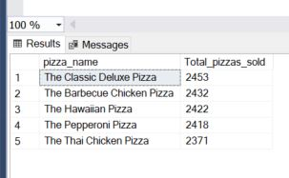

**Q7. Bottom 5 sellers by total pizzas sold**

select top 5 pizza_name, SUM(quantity) as Total_pizzas_sold

from pizza_sales

group by pizza_name

order by SUM(quantity)

